ASSESSMENT -5

NAME: C. PAVANI
REG NO:192524260
CSA1006-SOFTWARE ENGINEERING

1. Explain Technical Debt. What are the Major Causes of Technical Debt, and How Can Organizations Minimize It During Software Evolution?

Introduction
Technical debt is the accumulated cost of choosing a quick, temporary, or less-than-ideal technical solution instead of implementing the best long-term solution. It is similar to financial debt: a small amount may help an organization deliver a feature quickly, but if it is not repaid through refactoring and maintenance, the cost increases over time. Technical debt can affect code, architecture, testing, documentation, infrastructure, security, and development processes.

Types of Technical Debt
- Code debt – duplicated, complex, poorly structured, or difficult-to-maintain code.
- Architecture debt – design decisions that make scaling, integration, or future changes difficult.
- Test debt – insufficient automated tests and poor regression coverage.
- Documentation debt – outdated or missing technical and system documentation.
- Dependency debt – old libraries, frameworks, runtimes, and third-party components.
- Infrastructure debt – outdated deployment, build, monitoring, or infrastructure configurations.
- Security debt – known vulnerabilities or insecure design choices that have not been corrected.

Major Causes of Technical Debt
- Short project deadlines and pressure for rapid releases.
- Business pressure to deliver features before improving internal quality.
- Frequent changes in requirements, priorities, or product direction.
- Poor software architecture and design decisions made without considering future growth.
- Insufficient testing, especially unit, integration, and regression testing.
- Copy-paste programming, duplicated logic, and unnecessarily complex code.
- Skipping code reviews or ignoring coding standards.
- Use of outdated frameworks, libraries, operating systems, or development tools.
- Lack of documentation and loss of knowledge when team members change.
- Insufficient refactoring because maintenance work is treated as less important than new features.
- Poor communication between developers, testers, operations teams, and business stakeholders.
- Temporary workarounds becoming permanent parts of the system.

Effects of Technical Debt
- Slower development and longer release cycles.
- More software defects and production failures.
- Higher maintenance and operational costs.
- Difficulty adding new features or changing existing functionality.
- Poor application performance and scalability.
- Increased security and compliance risks.
- More difficult onboarding of new developers.
- Reduced reliability and customer satisfaction.
- Greater probability of large and expensive future refactoring projects.

How Organizations Can Minimize Technical Debt During Software Evolution
- Perform regular code reviews and enforce coding standards.
- Use automated unit, integration, system, and regression testing.
- Reserve time in every development cycle for refactoring and maintenance.
- Use static code analysis and quality gates to detect problems early.
- Keep third-party dependencies and frameworks updated.
- Use modular and maintainable architectures with clear interfaces.
- Document important architecture decisions, APIs, and deployment procedures.
- Track technical debt as backlog items and prioritize debt according to risk and business impact.
- Use CI/CD pipelines to automatically build, test, scan, and validate changes.
- Monitor application performance, reliability, and security continuously.
- Use incremental modernization instead of allowing old systems to remain unchanged for many years.
- Conduct technical-debt reviews during major releases and architecture changes.

Conclusion
Technical debt cannot always be completely avoided because software projects face deadlines and changing requirements. However, organizations can control it by combining good architecture, code reviews, automated testing, refactoring, documentation, dependency management, monitoring, and continuous improvement. Managing technical debt throughout software evolution keeps systems maintainable, secure, scalable, and reliable.

Flow Chart
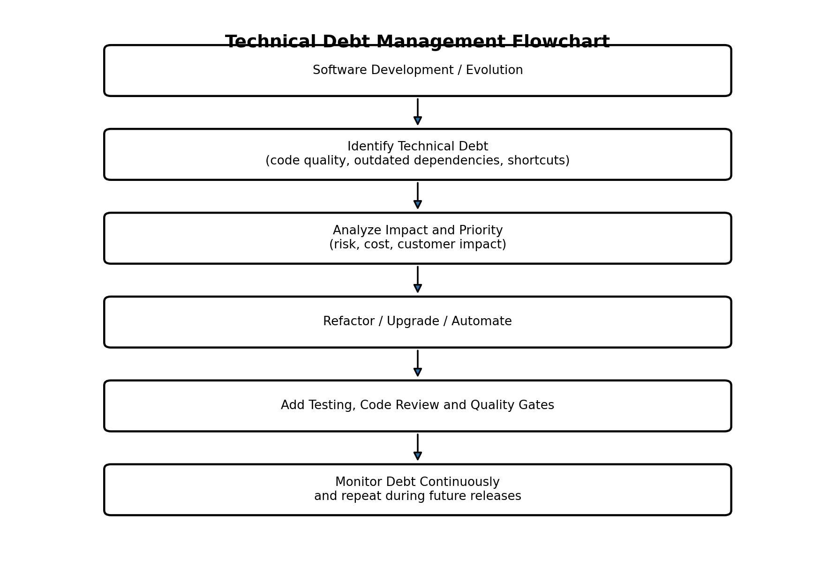

2. Explain How AI/ML and Edge Computing are Transforming Modern Software Engineering. Provide One Practical Example for Each.

Introduction
Artificial Intelligence (AI), Machine Learning (ML), and Edge Computing are changing how modern software is designed, developed, deployed, and operated. AI/ML adds intelligence and automation to software, while Edge Computing moves computation closer to the devices and users generating data. Together, they improve automation, responsiveness, scalability, personalization, and operational efficiency.

AI/ML in Modern Software Engineering
AI/ML enables software systems to learn patterns from data and make predictions or decisions. It is being used throughout the software development life cycle, from coding and testing to deployment and monitoring.
- AI-assisted coding – helps developers generate code, explain code, and suggest improvements.
- Automated testing – ML can help generate test cases and identify areas likely to contain defects.
- Defect prediction – historical development data can be analyzed to predict modules that may contain bugs.
- Anomaly detection – ML models can identify unusual application behavior, traffic patterns, or system failures.
- Predictive maintenance – models can predict equipment or service failures before they occur.
- Intelligent monitoring – AI can correlate logs, metrics, and events to identify possible incidents.
- Personalization – software can provide recommendations based on user behavior.
- Natural language interfaces – users can interact with applications using conversational language.
- Security – AI/ML can help detect suspicious behavior, fraud, malware, and abnormal network activity.
- Process automation – repetitive development and operational tasks can be automated.

Practical AI/ML Example – Predictive Maintenance
In a manufacturing system, sensors collect temperature, vibration, pressure, and power-consumption data from machines. An ML model learns from historical sensor readings and previous failures. When the model detects a pattern associated with a possible failure, the system sends an alert to maintenance staff. This allows maintenance to be scheduled before the machine breaks down, reducing downtime, repair costs, and production loss.

Edge Computing in Modern Software Engineering
Edge Computing processes data near the source of data generation, such as cameras, sensors, vehicles, industrial machines, or mobile devices, instead of sending every piece of data to a centralized cloud. This is especially useful for applications that require fast responses.
- Low latency – decisions can be made close to the device.
- Reduced bandwidth usage – only necessary or summarized data needs to be sent to the cloud.
- Improved availability – local processing can continue even when cloud connectivity is temporarily poor.
- Better privacy – sensitive data can sometimes be processed locally instead of being transmitted.
- Real-time applications – suitable for robotics, traffic control, industrial monitoring, and smart devices.
- Distributed processing – workloads can be shared between edge devices and cloud systems.
- Scalability – large volumes of sensor data can be filtered before reaching centralized systems.
- Lower network dependency – applications can respond without waiting for a remote server.

Practical Edge Computing Example – Smart Traffic Monitoring
Traffic cameras and roadside sensors can use edge devices to analyze vehicles locally. The edge system can detect congestion, accidents, or unusual traffic conditions immediately. Instead of sending continuous video streams to the cloud, it can send only important events and summarized information. This reduces bandwidth usage and allows traffic-control systems to respond quickly.

Overall Benefits
- Faster and more intelligent decision-making.
- Improved application performance and responsiveness.
- Reduced manual effort for developers and operations teams.
- Better prediction of failures and system problems.
- Lower network bandwidth requirements for edge workloads.
- Improved scalability for data-intensive applications.
- Support for real-time and autonomous applications.
- Better user experience through personalization and low-latency processing.

Conclusion
AI/ML makes software more intelligent by learning from data and automating decisions, while Edge Computing makes software more responsive by processing data closer to its source. AI/ML is valuable for prediction, automation, testing, and anomaly detection, whereas Edge Computing is valuable for low-latency and distributed applications. Both technologies are important parts of modern software engineering.

Flow Chart
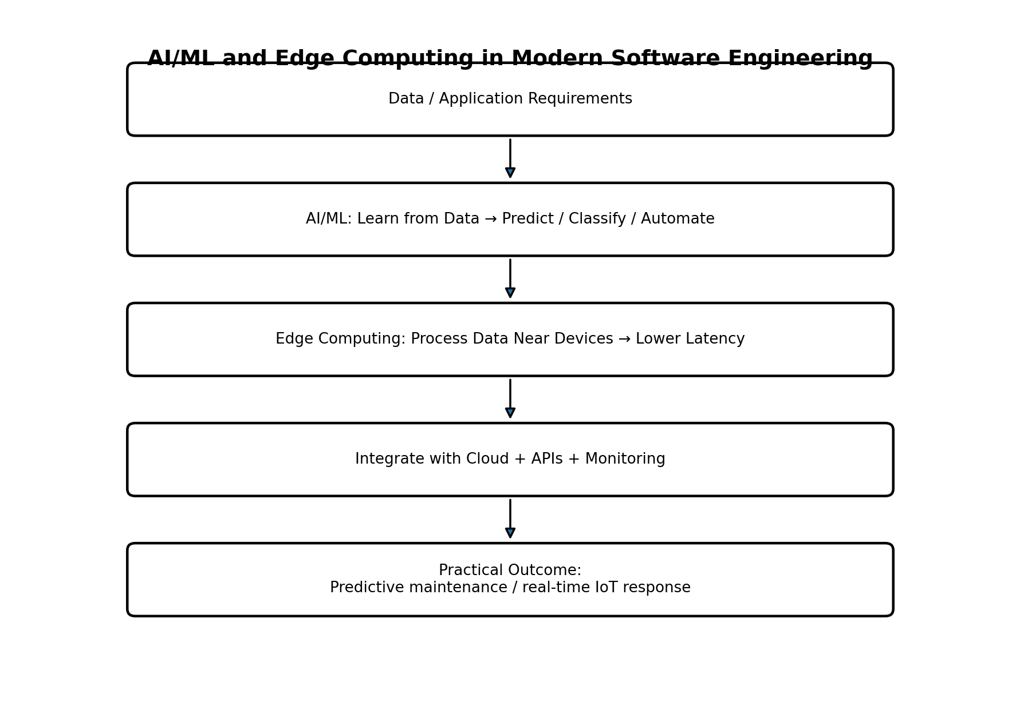

3. Case Study – Sustainable DevOps for Cloud Microservices

Case Study
A company has deployed dozens of microservices in the cloud. As the number of services and users grows, CPU usage, memory consumption, storage, network traffic, and energy consumption also increase. If resources are not managed efficiently, the company may pay for unused capacity and consume more energy than necessary. Sustainable DevOps, or Green DevOps, combines DevOps automation with resource and energy efficiency.

Practice 1: Right-Sizing and Autoscaling
Right-sizing means selecting CPU, memory, storage, and instance types according to actual workload needs. Teams should analyze monitoring data instead of assigning excessive resources to every microservice. Autoscaling can increase capacity during peak traffic and reduce capacity during low-demand periods.
- Analyze CPU and memory utilization for each microservice.
- Remove or reduce over-provisioned instances.
- Configure horizontal and vertical autoscaling where appropriate.
- Scale services down during nights or low-traffic periods.
- Use workload-based resource limits and requests.
- Regularly review cloud resource utilization.
Benefit: Less idle infrastructure, lower energy consumption, and lower cloud cost.

Practice 2: Container and Microservice Optimization
Efficient containers can reduce unnecessary resource usage. Organizations should use lightweight container images, remove unused dependencies, set appropriate CPU and memory limits, and avoid running unnecessary replicas. Efficient scheduling can also consolidate workloads onto fewer machines when safe.
- Use small and optimized container images.
- Remove unused containers and services.
- Set realistic CPU and memory requests and limits.
- Reduce unnecessary replicas during low demand.
- Use efficient orchestration and scheduling.
- Optimize service communication to reduce unnecessary network traffic.
Benefit: Better resource utilization and reduced compute and networking costs.

Practice 3: Green CI/CD and Energy-Aware Operations
CI/CD pipelines can consume significant compute resources when builds and tests are run unnecessarily. Teams can reduce this waste by using caching, incremental builds, selective testing, parallel execution where it reduces total runtime, and automatic cleanup of temporary resources. Monitoring should also include cost and resource-utilization indicators.
- Use dependency and build caching.
- Run only relevant tests for small changes while retaining complete testing at appropriate stages.
- Use incremental builds instead of rebuilding everything unnecessarily.
- Delete temporary environments and unused artifacts automatically.
- Schedule heavy non-urgent workloads during appropriate periods when possible.
- Monitor cloud cost, CPU, memory, storage, and network usage.
- Create dashboards and alerts for unusually high resource consumption.
Benefit: Shorter and more efficient pipelines, lower compute consumption, and reduced cloud cost.

Additional Sustainable DevOps Practices
- Use managed cloud services efficiently and avoid unnecessary always-on infrastructure.
- Optimize storage by removing obsolete data and using appropriate storage tiers.
- Use efficient application algorithms and caching to reduce compute requirements.
- Monitor and optimize database queries to reduce CPU and I/O consumption.
- Use observability to identify idle or inefficient microservices.
- Set sustainability and cost targets alongside performance and reliability targets.

Expected Results
- Reduced cloud infrastructure cost.
- Lower electricity and energy consumption.
- Reduced idle CPU and memory capacity.
- Improved utilization of containers and virtual machines.
- More efficient software delivery pipelines.
- Better environmental sustainability without sacrificing service reliability.

Conclusion
Sustainable DevOps helps organizations reduce the environmental and financial impact of cloud software. Right-sizing and autoscaling prevent over-provisioning, container and microservice optimization reduces wasted compute capacity, and green CI/CD reduces unnecessary build and deployment work. By continuously measuring resource usage, cost, and performance, organizations can create cloud systems that are efficient, scalable, reliable, and environmentally responsible.

Flow Chart
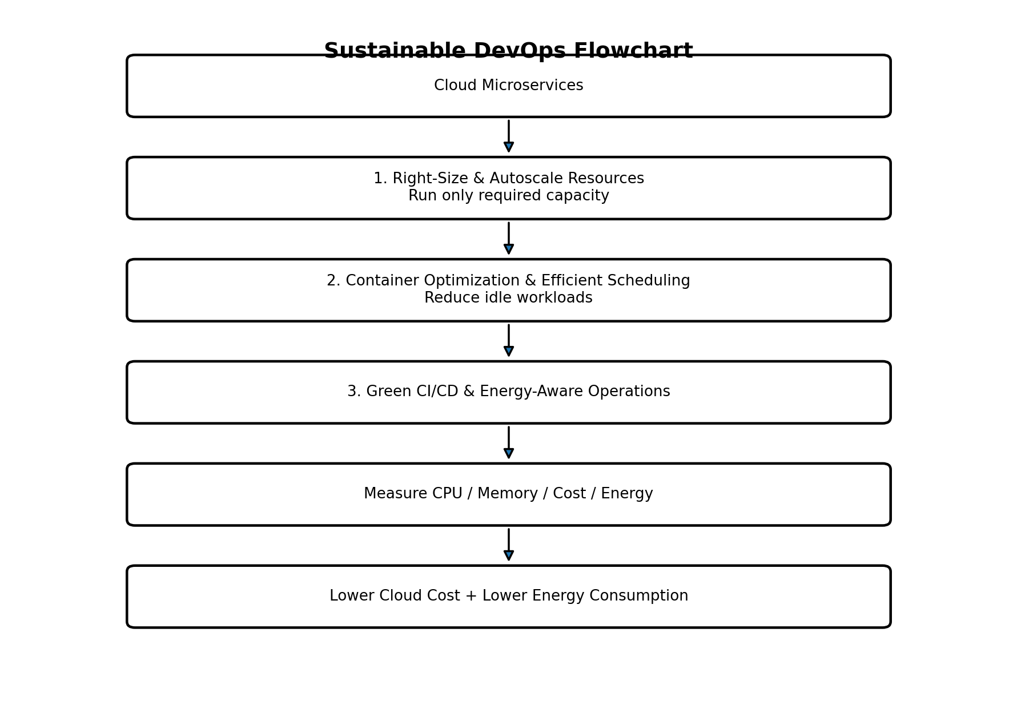

Final Summary
Technical debt management supports long-term maintainability; AI/ML improves intelligence and automation; Edge Computing improves real-time responsiveness; and Sustainable DevOps improves cloud resource efficiency. Together, these practices help organizations build software that is maintainable, intelligent, responsive, cost-effective, reliable, and sustainable.

